

**AGRICULTURAL PRODUCT SHOPPING APP**

**BY**

**USING SQL**

Submitted by

SHRI DHARSHINI M (231501153)

ROSHNI P.K (231501137)

RANJANI SAI SD (231501130)

**CS23332 – DATABASE MANAGEMENT SYSTEM**

Department of Artificial Intelligence and Machine Learning

Rajalakshmi Engineering College, Thandalam

BONAFIDE CERTIFICATE

This is to certify that the Mini project work titled “**AGRICULTURE**

**PRODUCT SHOPPING APP BY USING SQL”** done by, SHRI DHARSHINI M (231501153), ROSHNI P.K (231501137), RANJANI SD (231501130) is a record of Bonafide work carried out by him/her under my supervision as a part of MINI PROJECT for the subject CS23332 - DATABASE MANAGEMENT SYSTEM by Department of Artificial Intelligence and Machine Learning.

SIGNATURE SIGNATURE

INTERNAL EXAMINER EXTERNAL EXAMINER

**TABLE OF CONTENTS:**

|  |  |  |
| --- | --- | --- |
| **S. No** | **Chapter** | **Page Number** |
| 1. | PROBLEM STATEMENT |  |
| 2. | NOVELTY |  |
| 3. | KEY FEATURES |  |
| 4. | IMPACTS |  |
| 5. | FUNDAMENTALS FOR DATABASE |  |
| 6. | TECH STACK |  |
| 7. | QUERIES |  |
| 8. | ER DIAGRAM |  |
| 9. | RESULT |  |
| 10. | CONCLUSION |  |
| 11. | REFERENCES |  |

AGROBUY

**PROBLEM STATEMENT:**

Small-scale farmers often encounter challenges like limited market access, unfair pricing, and inefficient supply chains, which impact their economic stability and growth. This project aims to develop a comprehensive digital marketplace that directly links farmers with buyers, providing transparency, fair pricing, and efficient transaction management. By facilitating better market access and resource-sharing, the platform will empower farmers, support sustainable agricultural practices, and enhance overall livelihoods in rural communities.

**NOVELTY:**

Targeted Farmer-Buyer Matching: Unlike existing platforms, this solution utilizes an innovative approach to connect farmers with buyers based on specific criteria such as crop type, geographic location, and seasonal demand, facilitating tailored interactions without needing extensive prior data.

Dynamic Price Optimization: An adaptive pricing model updates in real-time to reflect current market conditions, ensuring fair and competitive pricing for farmers. Following the initial matching, a recommendation system employs machine learning to suggest optimal sale timings and crop selections, enhancing profitability and reducing waste.

**KEY FEATURES:**

- Seamless Farmer Registration: A straightforward registration process for farmers to create profiles and list their produce, ensuring quick onboarding to the marketplace.

- Buyer Discovery Tools: Advanced search and filtering options that enable buyers to find specific products based on criteria like location, crop type, and pricing.

- Transparent Rating System: A built-in rating and review system that allows buyers to evaluate farmers based on product quality and service, fostering trust within the community.

- Inventory Management: Tools for farmers to manage their inventory in real time, allowing them to update available quantities and product details efficiently.

- Community Forum: A dedicated space for farmers to connect, share experiences, and exchange advice on best practices, enhancing collaboration and support within the agricultural community.

**IMPACTS:**

- Empowers Small-Scale Farmers: By facilitating direct connections between farmers and buyers, the platform enhances market access and improves pricing, significantly boosting farmers' economic stability.

- Promotes Sustainable Agriculture: The platform provides resources and insights on sustainable farming practices, encouraging environmentally friendly methods that benefit both farmers and the community.

**POTENTIAL FUTURE APPLICATION:**

- Expansion to Additional Products: The platform can be adapted to include a wider variety of agricultural products, enabling farmers to diversify their offerings and buyers to access a broader range of goods.

- Data-Driven Agricultural Insights: The platform could leverage collected data to provide farmers with insights into market trends, crop performance, and buyer preferences, helping them make informed decisions and optimize their production strategies.

- Collaboration with Agricultural Agencies: Future applications may include partnerships with government and non-profit agricultural organizations to provide training programs and resources that enhance farmers’ skills and knowledge, promoting community development and agricultural sustainability.

**FUNDAMENTAL FOR DATABASE:**

- Key Attributes: The database will store essential product attributes such as product ID, name, category (e.g., fruits, vegetables), price, and geographic location. Each product will have these attributes as individual columns to facilitate efficient searching and filtering by buyers.

- User Profiles: The database will maintain profiles for both farmers and buyers, linked to unique user IDs. Each user profile will include essential information such as contact details, demographics, and transaction history, enabling personalized user experiences.

- Transactional Data: The database will track transactional information, including orders placed, payment status, and delivery details, ensuring comprehensive record-keeping of all marketplace activities.

- Product Reviews and Ratings: The system will capture user-generated reviews and ratings for products, which will help build trust among users and provide feedback for continuous improvement of the marketplace.

- Inventory Management: The database will allow farmers to update their product availability in real-time, ensuring accurate listings and helping them manage their inventory effectively.

- Market Insights: A section dedicated to storing market analytics, including trends and buyer preferences, will help farmers make informed decisions regarding their offerings and pricing strategies.

**TECH STACK:**

- Frontend:

- HTML: For structuring the content of the web application.

- CSS: For styling the web application, ensuring it is visually appealing and user-friendly.

- Backend: - PHP: For server-side scripting to manage data interactions and business logic.

- Database - MySQL: For storing user, product, and transaction data in a structured format.

**QUERIES:**

CREATE TABLE `blogdata` (

`blogId` int(10) NOT NULL,

`blogUser` varchar(256) NOT NULL,

`blogTitle` varchar(256) NOT NULL,

`blogContent` longtext NOT NULL,

`blogTime` timestamp NOT NULL DEFAULT CURRENT_TIMESTAMP,

`likes` int(10) NOT NULL DEFAULT '0'

)

INSERT INTO `blogdata` (`blogId`, `blogUser`, `blogTitle`, `blogContent`, `blogTime`, `likes`) VALUES

(19, ‘ROSHNI’,’WEB’,’NICE WEBSITE’)

CREATE TABLE `blogfeedback` (

`blogId` int(10) NOT NULL,

`comment` varchar(256) NOT NULL,

`commentUser` varchar(256) NOT NULL,

`commentPic` varchar(256) NOT NULL DEFAULT 'profile0.png',

`commentTime` timestamp NOT NULL DEFAULT CURRENT_TIMESTAMP

)

INSERT INTO `blogfeedback` (`blogId`, `comment`, `commentUser`) VALUES

(19, 'helpful', 'ranjani');

CREATE TABLE `buyer` (

`bid` int(100) NOT NULL,

`bname` varchar(100) NOT NULL,

`busername` varchar(100) NOT NULL,

`bpassword` varchar(100) NOT NULL,

`bhash` varchar(100) NOT NULL,

`bemail` varchar(100) NOT NULL,

`bmobile` varchar(100) NOT NULL,

`baddress` text NOT NULL,

`bactive` int(100) NOT NULL DEFAULT '0'

)

CREATE TABLE `farmer` (

`fid` int(255) NOT NULL,

`fname` varchar(255) NOT NULL,

`fusername` varchar(255) NOT NULL,

`fpassword` varchar(255) NOT NULL,

`fhash` varchar(255) NOT NULL,

`femail` varchar(255) NOT NULL,

`fmobile` varchar(255) NOT NULL,

`faddress` text NOT NULL,

`factive` int(255) NOT NULL DEFAULT '0',

`frating` int(11) NOT NULL DEFAULT '0',

`picExt` varchar(255) NOT NULL DEFAULT 'png',

`picStatus` int(10) NOT NULL DEFAULT '0'

)

INSERT INTO `farmer` (`fid`, `fname`, `fusername`, `fpassword`, `fhash`, `femail`, `fmobile`, `faddress`, `factive`, `frating`, `picExt`, `picStatus`) VALUES

(3, 'Kaivalya Hemant Mendki', 'ThePhenom', '$2y$10$22ezmzHRa9c5ycHmVm5RpOnlT4LwFaDZar1XhmLRJQKGrcVRhPgti', '61b4a64be663682e8cb037d9719ad8cd', 'kmendki98@gmail.com', '8600611198', 'abcde', 0, 0, 'png', 0);

CREATE TABLE `fproduct` (

`fid` int(255) NOT NULL,

`pid` int(255) NOT NULL,

`product` varchar(255) NOT NULL,

`pcat` varchar(255) NOT NULL,

`pinfo` varchar(255) NOT NULL,

`price` float NOT NULL,

`pimage` varchar(255) NOT NULL DEFAULT 'blank.png',

`picStatus` int(10) NOT NULL DEFAULT '0'

)

INSERT INTO `fproduct` (`fid`, `pid`, `product`, `pcat`, `pinfo`, `price`, `pimage`, `picStatus`) VALUES

(3, 27, 'Mango', 'Fruit', '<p>Mango for sale</p>\r\n', 500, 'Mango3.jpeg', 1),

(3, 28, 'Ladyfinger', 'Vegetable', '<p>for sale </p>\r\n', 1000, 'Ladyfinger3.jpg', 1),

(3, 30, 'Banana', 'Fruit', '<p>banana for sale </p>\r\n', 400, 'Banana3.jpg', 1);

CREATE TABLE `likedata` (

`blogId` int(10) NOT NULL,

`blogUserId` int(10) NOT NULL

)

INSERT INTO `likedata` (`blogId`, `blogUserId`) VALUES

(19, 3);

CREATE TABLE `mycart` (

`bid` int(10) NOT NULL,

`pid` int(10) NOT NULL

)

INSERT INTO `mycart` (`bid`, `pid`) VALUES

(3, 27),

(3, 30);

CREATE TABLE `review` (

`pid` int(10) NOT NULL,

`name` varchar(255) NOT NULL,

`rating` int(10) NOT NULL,

`comment` text NOT NULL

)

CREATE TABLE `transaction` (

`tid` int(10) NOT NULL,

`bid` int(10) NOT NULL,

`pid` int(10) NOT NULL,

`name` varchar(255) NOT NULL,

`city` varchar(255) NOT NULL,

`mobile` varchar(255) NOT NULL,

`email` varchar(255) NOT NULL,

`pincode` varchar(255) NOT NULL,

`addr` varchar(255) NOT NULL

) ENGINE=InnoDB DEFAULT CHARSET=latin1;

INSERT INTO `transaction` (`tid`, `bid`, `pid`, `name`, `city`, `mobile`, `email`, `pincode`, `addr`) VALUES

(1, 3, 28, 'sa,j,cns', 'sajc', 'sajch', 'kmendki98@gmail.com', 'sacu', 'ckaskjc');

ALTER TABLE `blogdata`

ADD PRIMARY KEY (`blogId`);

ALTER TABLE `buyer`

ADD PRIMARY KEY (`bid`),

ADD UNIQUE KEY `bid` (`bid`);

ALTER TABLE `farmer`

ADD PRIMARY KEY (`fid`),

ADD UNIQUE KEY `fid` (`fid`);

ALTER TABLE `fproduct`

ADD PRIMARY KEY (`pid`);

ALTER TABLE `likedata`

ADD KEY `blogId` (`blogId`),

ADD KEY `blogUserId` (`blogUserId`);

ALTER TABLE `transaction`

ADD PRIMARY KEY (`tid`);

ALTER TABLE `blogdata`

MODIFY `blogId` int(10) NOT NULL AUTO_INCREMENT, AUTO_INCREMENT=20;

ALTER TABLE `buyer`

MODIFY `bid` int(100) NOT NULL AUTO_INCREMENT;

ALTER TABLE `farmer`

MODIFY `fid` int(255) NOT NULL AUTO_INCREMENT, AUTO_INCREMENT=4;

ALTER TABLE `fproduct`

MODIFY `pid` int(255) NOT NULL AUTO_INCREMENT, AUTO_INCREMENT=31;

ALTER TABLE `transaction`

MODIFY `tid` int(10) NOT NULL AUTO_INCREMENT, AUTO_INCREMENT=2;

ALTER TABLE `buyer`

ADD CONSTRAINT `buyer_ibfk_1` FOREIGN KEY (`bid`) REFERENCES `farmer` (`fid`);

ALTER TABLE `likedata`

ADD CONSTRAINT `likedata_ibfk_1` FOREIGN KEY (`blogId`) REFERENCES `blogdata` (`blogId`);

FRONTEND-HTML AND CSS

<?php session_start(); ?>

<!DOCTYPE html>

<html lang="en">

<head>

<meta charset="UTF-8">

<title>AgroBuy</title>

<meta http-equiv="content-type" content="text/html; charset=utf-8" />

<meta name="description" content="" />

<meta name="keywords" content="" />

<link href="bootstrap/css/bootstrap.min.css" rel="stylesheet">

<script src="https://ajax.googleapis.com/ajax/libs/jquery/1.12.4/jquery.min.js"></script>

<script src="bootstrap/js/bootstrap.min.js"></script>

<!--[if lte IE 8]><script src="css/ie/html5shiv.js"></script><![endif]-->

<link rel="stylesheet" href="login.css"/>

<script src="js/jquery.min.js"></script>

<script src="js/skel.min.js"></script>

<script src="js/skel-layers.min.js"></script>

<script src="js/init.js"></script>

<noscript>

<link rel="stylesheet" href="css/skel.css" />

<link rel="stylesheet" href="css/style.css" />

<link rel="stylesheet" href="css/style-xlarge.css" />

</noscript>

<link rel="stylesheet" href="indexfooter.css" />

<!--[if lte IE 8]><link rel="stylesheet" href="css/ie/v8.css" /><![endif]-->

</head>

<body>

<class="" style=""><div id="skel-layers-wrapper" style="position: relative; left: 0px; right: 0px; top: 0px; backface-visibility: hidden; transition: -webkit-transform 0.5s, opacity 0.5s; z-index: auto; transform: translate(0px, 0px);">

<div id="skel-layers-wrapper" style="position: relative; left: 0px; right: 0px; top: 0px; backface-visibility: hidden; transition: -webkit-transform 0.5s, opacity 0.5s;">

<header id="header">

<h1><a href="index.php">AgroBuy</a></h1>

<div id="skel-layers-placeholder-nav"></div>

</header>

<section id="banner" class="wrapper">

<div class="container">

<h2>AgroBuy</h2>

<p>Your Product Our Market</p>

<br><br>

<center>

<div class="row uniform">

<div class="6u 12u$(xsmall)">

<button class="button fit" onclick="document.getElementById('id01').style.display='block'" style="width:auto">LOGIN</button>

</div>

<div class="6u 12u$(xsmall)">

<button class="button fit" onclick="document.getElementById('id02').style.display='block'" style="width:auto">REGISTER</button>

</div>

</div>

</center>

</div>

</section>

<!-- One -->

<!-- Footer -->

<footer class="footer-distributed" style="background-color:black" id="aboutUs">

<center>

<h1 style="font: 35px calibri;">About Us</h1>

</center>

<div class="footer-left">

<h3 style="font-family: 'Times New Roman', cursive;">AgroBuy © </h3>

<br>

<p style="font-size:20px;color:white">Your product Our market !!!</p>

<br>

</div>

<div class="footer-center">

<div>

<i class="fa fa-map-marker"></i>

<p style="font-size:20px">Chennai<span>REC</span></p>

</div>

<div>

<i class="fa fa-phone"></i>

<p style="font-size:20px">123456789</p>

</div>

<div>

<i class="fa fa-envelope"></i>

<p style="font-size:20px"><a href="mailto:AgroBuy@gmail.com" style="color:white">demo@demo.com</a></p>

</div>

</div>

<div class="footer-right">

<p class="footer-company-about" style="color:white">

<span style="font-size:20px"><b>About AgroBuy</b></span>

AgroBuy is an e-commerce trading platform for grains &amp; groceries...

</p>

<div class="footer-icons">

<a href="#"><i style="margin-left: 0;margin-top:5px;" class="fa fa-facebook"></i></a>

<a href="#"><i style="margin-left: 0;margin-top:5px" class="fa fa-instagram"></i></a>

<a href="#"><i style="margin-left: 0;margin-top:5px" class="fa fa-youtube"></i></a>

</div>

</div>

</footer>

<div id="id01" class="modal">

<form class="modal-content animate" action="Login/login.php" method="POST">

<div class="imgcontainer">

<span onclick="document.getElementById('id01').style.display='none'" class="close" title="Close Modal">×</span>

</div>

<div class="container">

<h3>Login</h3>

<div class="row uniform 50%">

<div class="7u$">

<input type="text" name="uname" id="uname" value="" placeholder="UserName" style="width:80%" required="">

</div>

<div class="7u$">

<input type="password" name="pass" id="pass" value="" placeholder="Password" style="width:80%" required="">

</div>

</div>

<div class="row uniform">

<p>

<b>Category : </b>

</p>

<div class="3u 12u$(small)">

<input type="radio" id="farmer" name="category" value="1" checked="">

<label for="farmer">Farmer</label>

</div>

<div class="3u 12u$(small)">

<input type="radio" id="buyer" name="category" value="0">

<label for="buyer">Buyer</label>

</div>

</div>

<center>

<div class="row uniform">

<div class="7u 12u$(small)">

<input type="submit" value="Login">

</div>

</div>

</center>

</div></form>

</div>

<div id="id02" class="modal">

<form class="modal-content animate" action="Login/signUp.php" method="POST">

<div class="imgcontainer">

<span onclick="document.getElementById('id02').style.display='none'" class="close" title="Close Modal">×</span>

</div>

<div class="container">

<h3>SignUp</h3>

<center>

<div class="row uniform">

<div class="3u 12u$(xsmall)">

<input type="text" name="name" id="name" value="" placeholder="Name" required="">

</div>

<div class="3u 12u$(xsmall)">

<input type="text" name="uname" id="uname" value="" placeholder="UserName" required="">

</div>

</div>

<div class="row uniform">

<div class="3u 12u$(xsmall)">

<input type="text" name="mobile" id="mobile" value="" placeholder="Mobile Number" required="">

</div>

<div class="3u 12u$(xsmall)">

<input type="email" name="email" id="email" value="" placeholder="Email" required="">

</div>

</div>

<div class="row uniform">

<div class="3u 12u$(xsmall)">

<input type="password" name="password" id="password" value="" placeholder="Password" required="">

</div>

<div class="3u 12u$(xsmall)">

<input type="password" name="pass" id="pass" value="" placeholder="Retype Password" required="">

</div>

</div>

<div class="row uniform">

<div class="6u 12u$(xsmall)">

<input type="text" name="addr" id="addr" value="" placeholder="Address" style="width:80%" required="">

</div>

</div>

<div class="row uniform">

<p>

<b>Category : </b>

</p>

<div class="3u 12u$(small)">

<input type="radio" id="farmer" name="category" value="1" checked="">

<label for="farmer">Farmer</label>

</div>

<div class="3u 12u$(small)">

<input type="radio" id="buyer" name="category" value="0">

<label for="buyer">Buyer</label>

</div>

</div>

<div class="row uniform">

<div class="3u 12u$(small)">

<input type="submit" value="Submit" name="submit" class="special">

</div>

<div class="3u 12u$(small)">

<input type="reset" value="Reset" name="reset">

</div>

</div>

</center>

</div></form>

</div>

<script>

// Get the modal

var modal = document.getElementById('id01');

// When the user clicks anywhere outside of the modal, close it

window.onclick = function(event) {

if (event.target == modal) {

modal.style.display = "none";

}

}

var modal1 = document.getElementById('id02');

// When the user clicks anywhere outside of the modal, close it

window.onclick = function(event) {

if (event.target == modal1) {

modal1.style.display = "none";

}

}

</script>

</div><div id="skel-layers-hiddenWrapper" style="height: 100%;"><div id="navPanel" class="skel-layer" style="backface-visibility: hidden; transition: -webkit-transform 0.5s, opacity 0.5s; z-index: 10000; position: fixed; display: none; overflow: hidden auto;"><div data-action="moveElement" data-args="nav"><div id="skel-layers-placeholder-nav"></div><div id="skel-layers-placeholder-nav"></div></div></div></div><div id="skel-layers-visibleWrapper" style="position: relative;"><div id="navButton" class="skel-layer skel-layer-top-left" style="backface-visibility: hidden; transition: -webkit-transform 0.5s, opacity 0.5s; z-index: 10004; position: fixed; display: block; max-width: 100%; max-height: 100%; width: 6em; height: 4em; top: 0px; left: 0px;"><span class="toggle" data-action="toggleLayer" data-args="navPanel" style="-webkit-tap-highlight-color: rgba(0, 0, 0, 0); cursor: pointer;"></span></div></div>

</div><div id="skel-layers-hiddenWrapper" style="height: 100%;"><div id="navPanel" class="skel-layer skel-layer-top-left" style="backface-visibility: hidden; transition: -webkit-transform 0.5s, opacity 0.5s; z-index: 10000; position: fixed; display: none; overflow: hidden auto; max-width: 100%; max-height: 100%; width: 250px; height: 100%; top: 0px; left: -250px; transform: translate(0px, 0px);"><div data-action="moveElement" data-args="nav"><div id="skel-layers-placeholder-nav"></div><nav id="nav" class="skel-layers-moved">

<ul>

<li><a href="index.php" style="-webkit-tap-highlight-color: rgba(0, 0, 0, 0);"><span class="glyphicon glyphicon-home"></span> Home</a></li>

<li><a href="myCart.php" style="-webkit-tap-highlight-color: rgba(0, 0, 0, 0);"><span class="glyphicon glyphicon-shopping-cart"> MyCart</span></a></li>

<li><a href="profileView.php" style="-webkit-tap-highlight-color: rgba(0, 0, 0, 0);"><span class="glyphicon glyphicon-user"></span> My Profile: SHRI</a></li>

<li><a href="market.php" style="-webkit-tap-highlight-color: rgba(0, 0, 0, 0);"><span class="glyphicon glyphicon-grain"> Digital-Market</span></a></li>

<li><a href="blogView.php" style="-webkit-tap-highlight-color: rgba(0, 0, 0, 0);"><span class="glyphicon glyphicon-comment"> BLOG</span></a></li>

</ul>

</nav></div></div></div><div id="skel-layers-visibleWrapper" style="position: relative;"><div id="navButton" class="skel-layer skel-layer-top-left" style="backface-visibility: hidden; transition: -webkit-transform 0.5s, opacity 0.5s; position: fixed; display: block; top: 0px; left: 0px; transform: translate(0px, 0px); max-width: 100%; max-height: 100%; width: 6em; height: 4em; z-index: 10004;"><span class="toggle" data-action="toggleLayer" data-args="navPanel" style="-webkit-tap-highlight-color: rgba(0, 0, 0, 0); cursor: pointer;"></span></div></div>

</body>

</html>

**ER DIAGRAM**

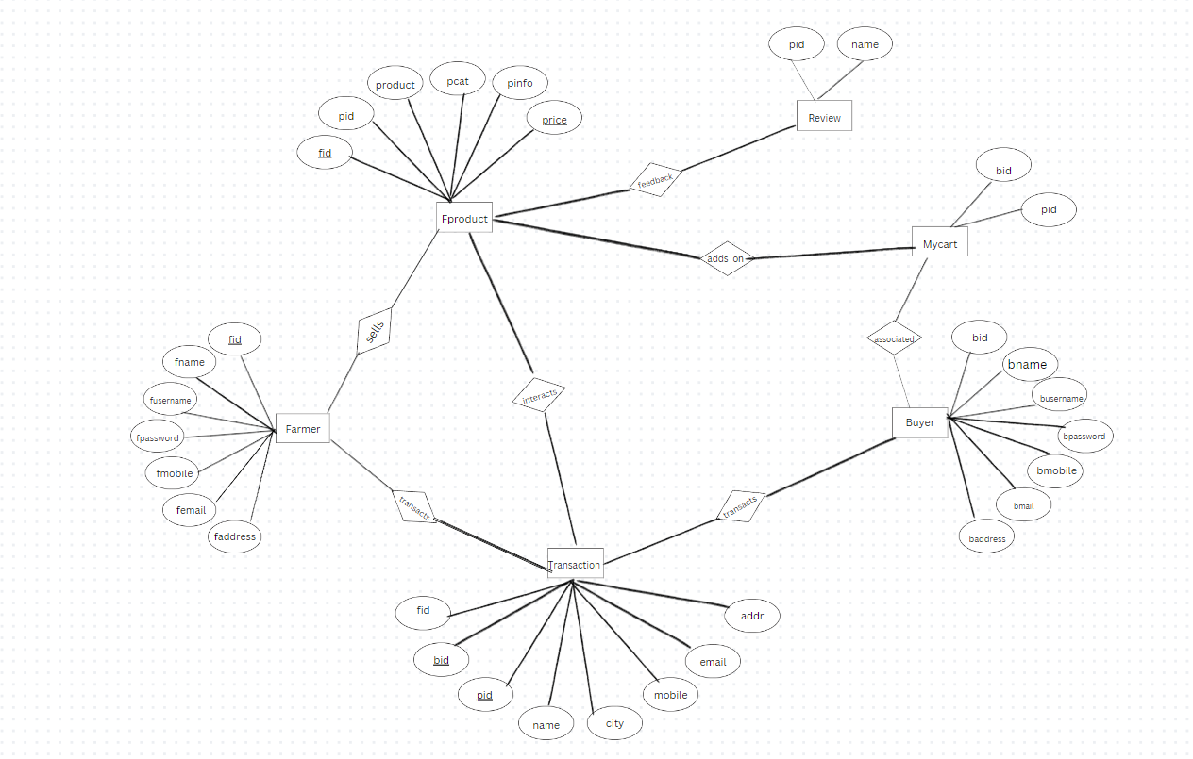

**RESULT:**

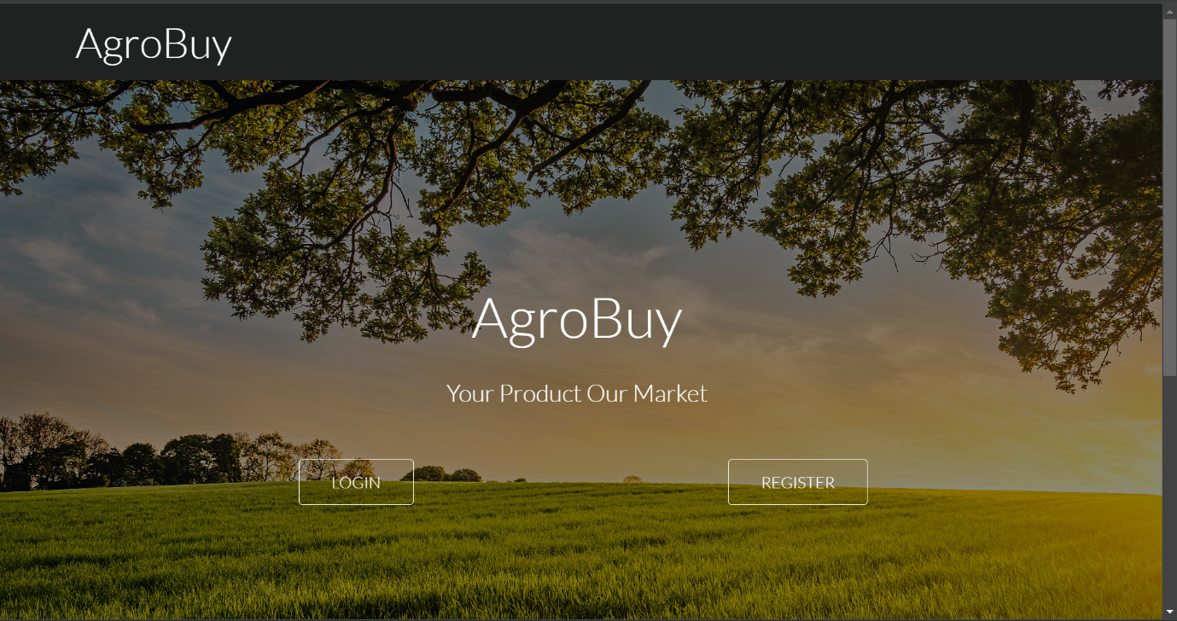

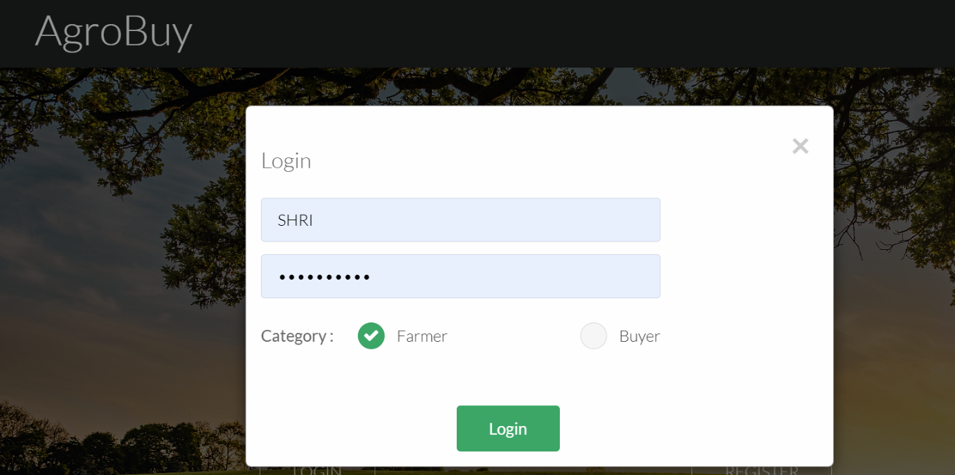

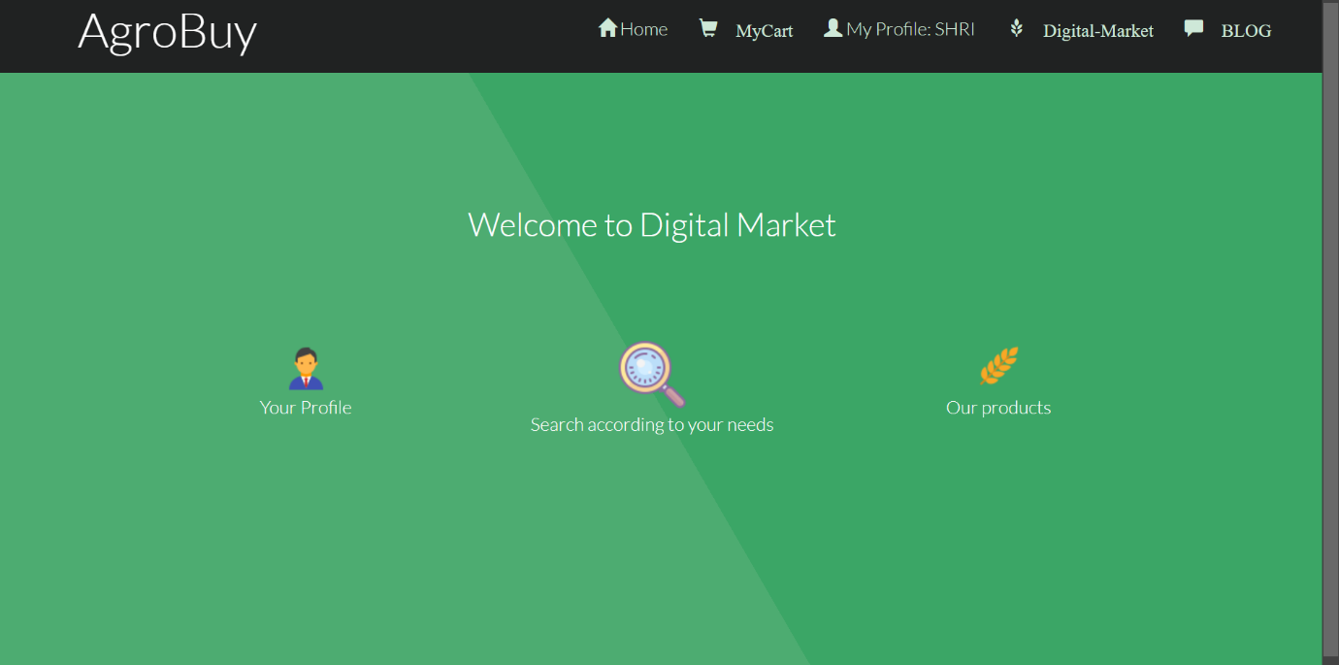

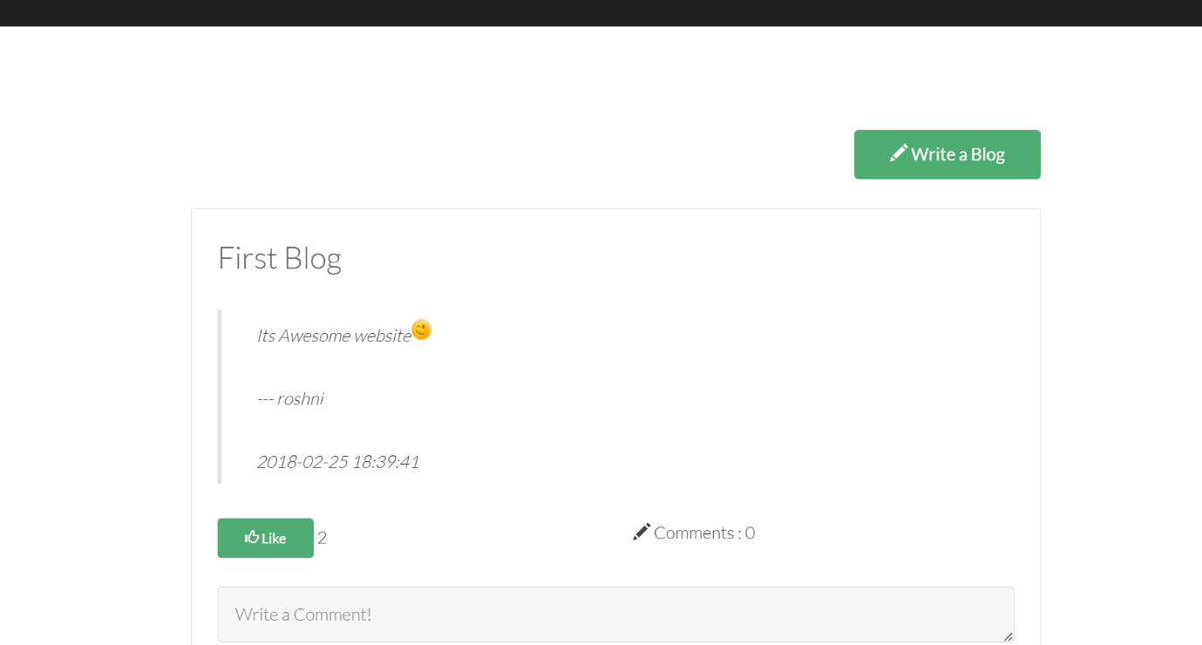

**CONCLUSION:**

The agricultural marketplace project effectively bridges the gap between farmers and buyers, facilitating efficient transactions in the agricultural sector. Utilizing HTML and CSS for the frontend and PHP with a MySQL database for the backend, the platform offers a user-friendly interface for product listings, user profiles, and feedback mechanisms. This project empowers farmers with better market access while providing buyers with transparent and informed purchasing options.

With potential for future enhancements such as mobile access and secure payment integration, this marketplace not only modernizes agricultural practices but also fosters a collaborative community. Overall, the project is a significant step toward enhancing efficiency and sustainability in the agricultural industry.

**REFERNCES:**

1. **W3Schools**: A comprehensive platform offering tutorials on HTML, SQL, PHP, and other web technologies. It includes interactive coding exercises and examples, making it a great starting point for beginners. [Visit W3Schools](https://www.w3schools.com/)
2. **Codecademy**: Provides beginner-friendly courses with hands-on projects for web development, including HTML, SQL, and PHP. [Visit Codecademy](https://www.codecademy.com/)
3. **FreeCodeCamp**: A non-profit platform offering free, self-paced coding lessons. It covers HTML and SQL as part of its full-stack development curriculum. [Visit FreeCodeCamp](https://www.freecodecamp.org/)【44†source】.
4. **The Odin Project**: Offers a step-by-step curriculum for learning web development. It includes modules on HTML, SQL, and PHP along with practical projects. [Visit The Odin Project](https://www.theodinproject.com/)【45†source】.
5. **PHP.net**: The official PHP documentation site is an excellent resource for learning PHP, with examples and in-depth explanations. [Visit PHP.net](https://www.php.net/)
6. **edX**: Provides free courses from top universities, including topics like SQL, HTML, and web programming. Some courses offer certification for a fee. [Visit edX](https://www.edx.org/)
7. **Udemy**: Hosts a wide range of courses on HTML, SQL, and PHP, both free and paid. The courses are user-reviewed, so you can find those most suitable for your learning level. [Visit Udemy](https://www.udemy.com/)【44†source】.